Integrus Website Update Guide
WC + Integrus
Table of Contents
General Instructions
Add a New Project
Homepage: Update Project or Blog/News
Update Filter Order for Projects
Add a New Blog/News Post
Add a New Team Member
Add a New Open Position

General Instructions
- Access the WordPress dashboard Here: https://integrusarch.com/wp-login.

Add a New Project
1. On the left sidebar click on Portfolio, where you will find all projects. You can click on add a new project or clone an existing one. By cloning, you will be able to use the previous project’s data as a guide but make sure you replace all of the old data.

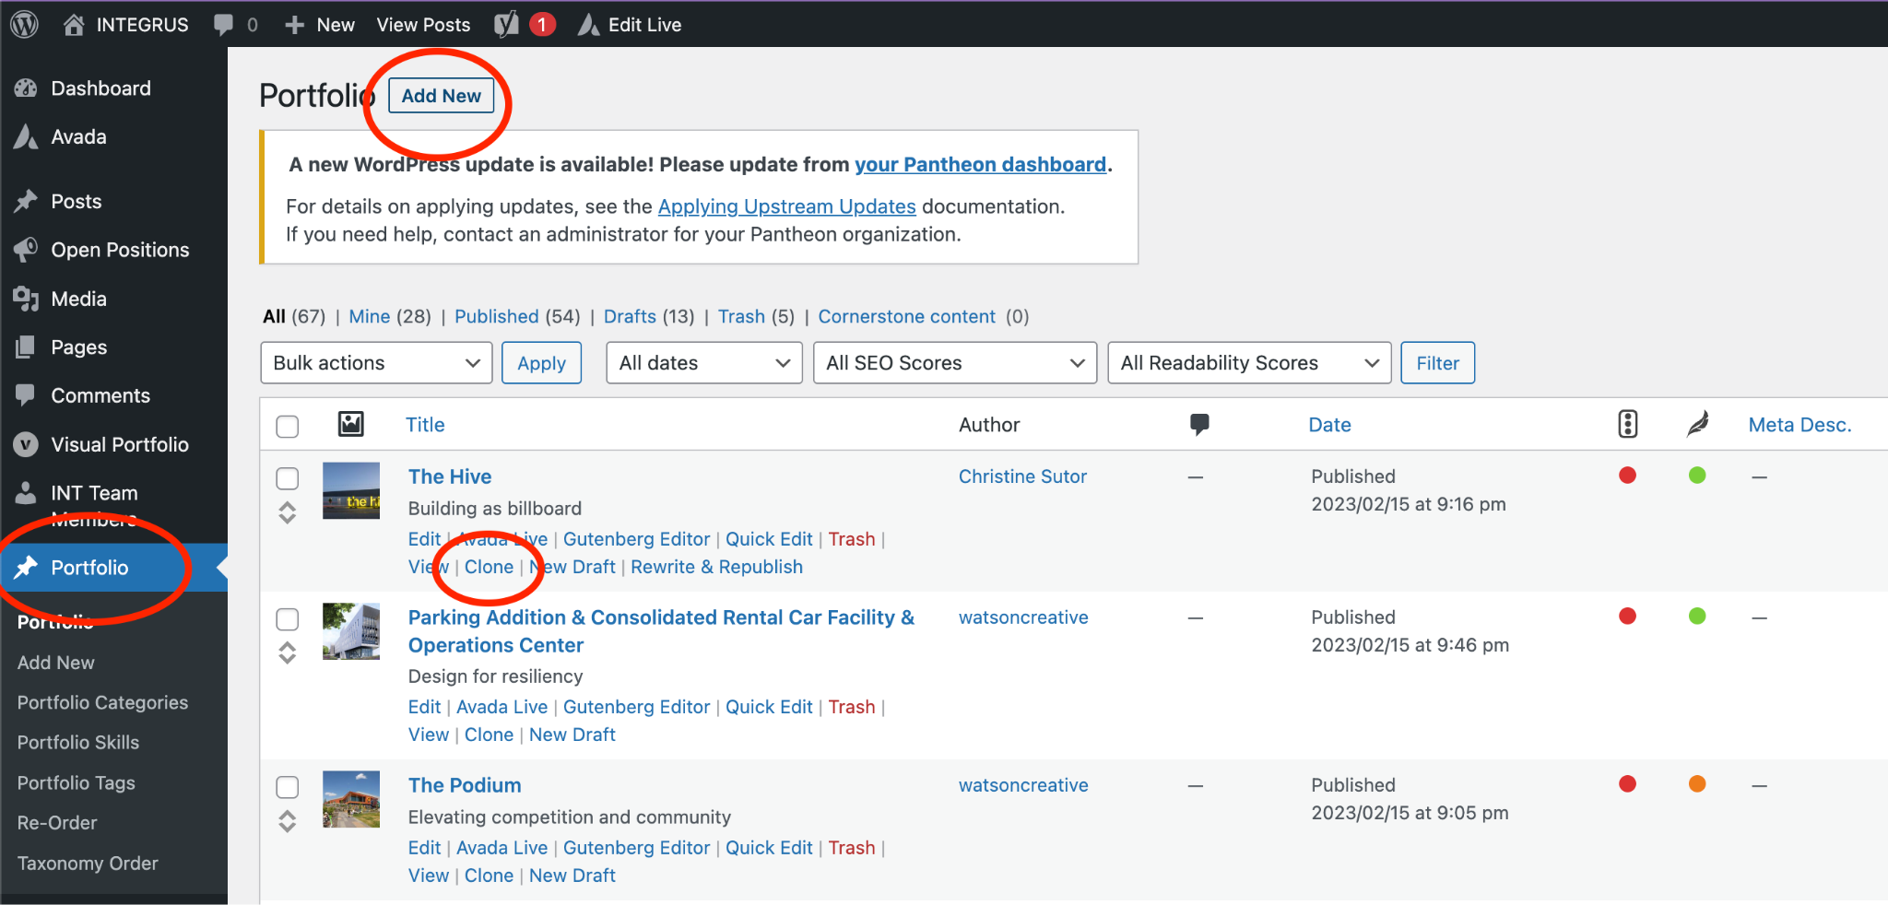

2. Replace the title and first text fields below with the information required.

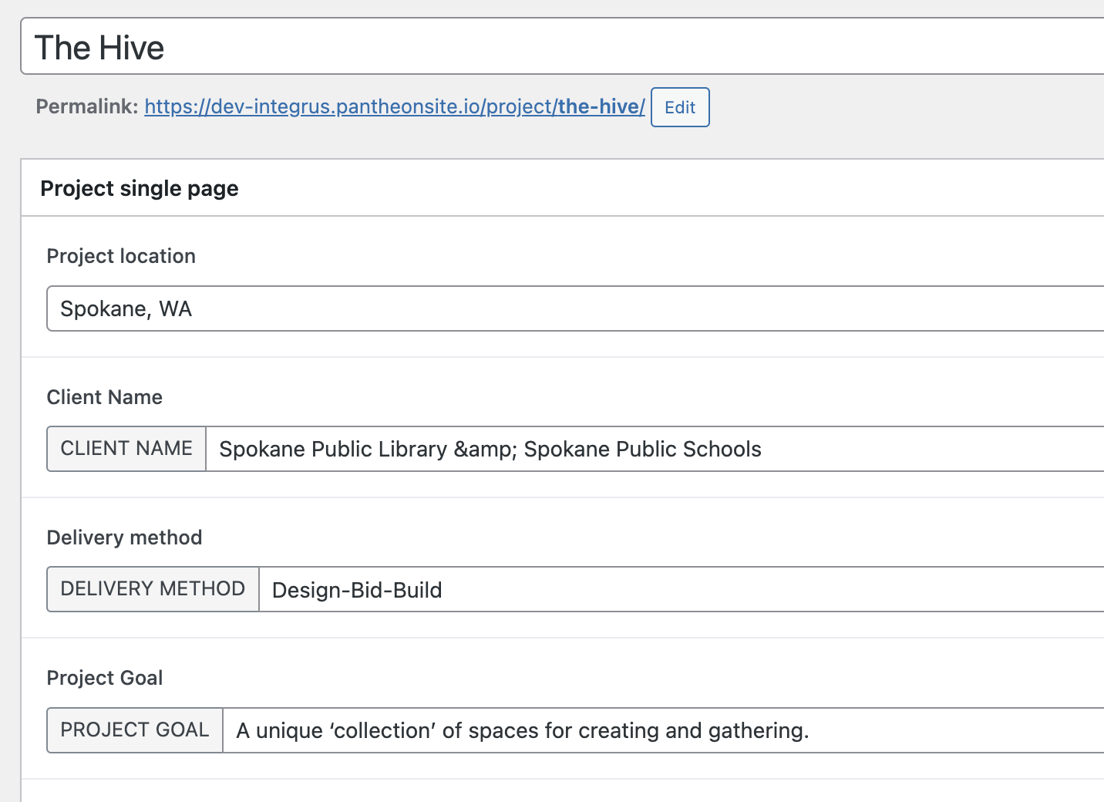

2.1 The screenshot below shows how those fields show up on the project page.
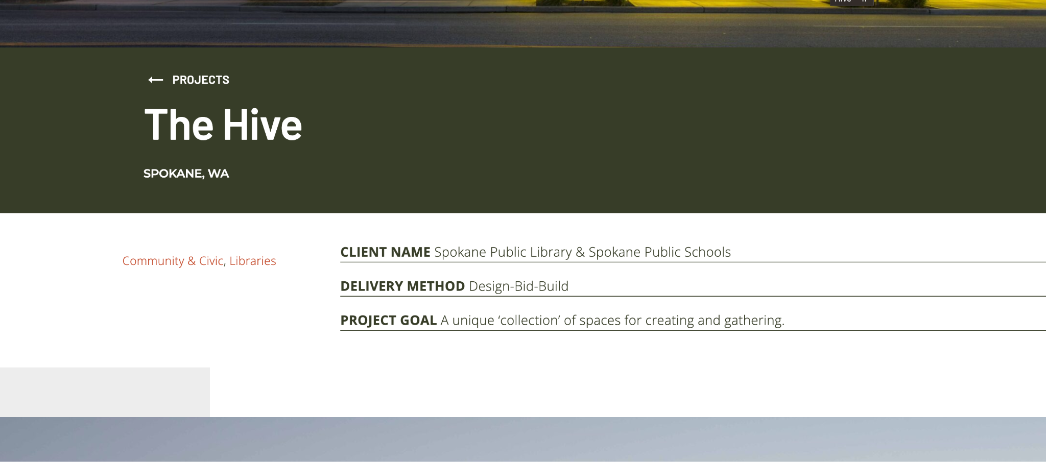

3. Below is a screenshot of the fields that follow and how they look on the final page. For Recognition, make sure that each item is separated by a break point. The bullets will be added automatically by the page styles.
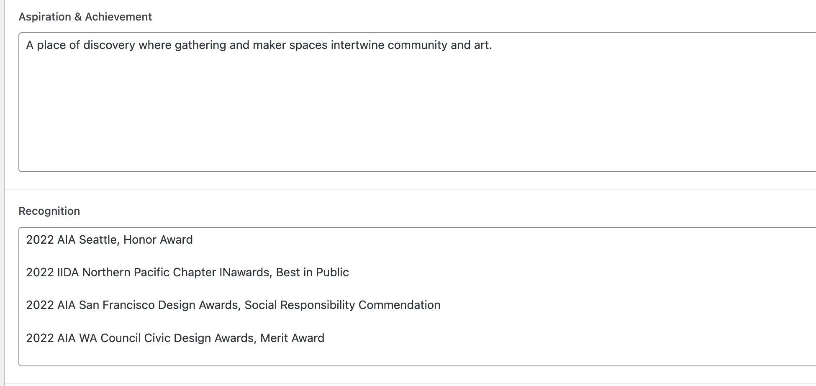

3.1 Here is how it looks:
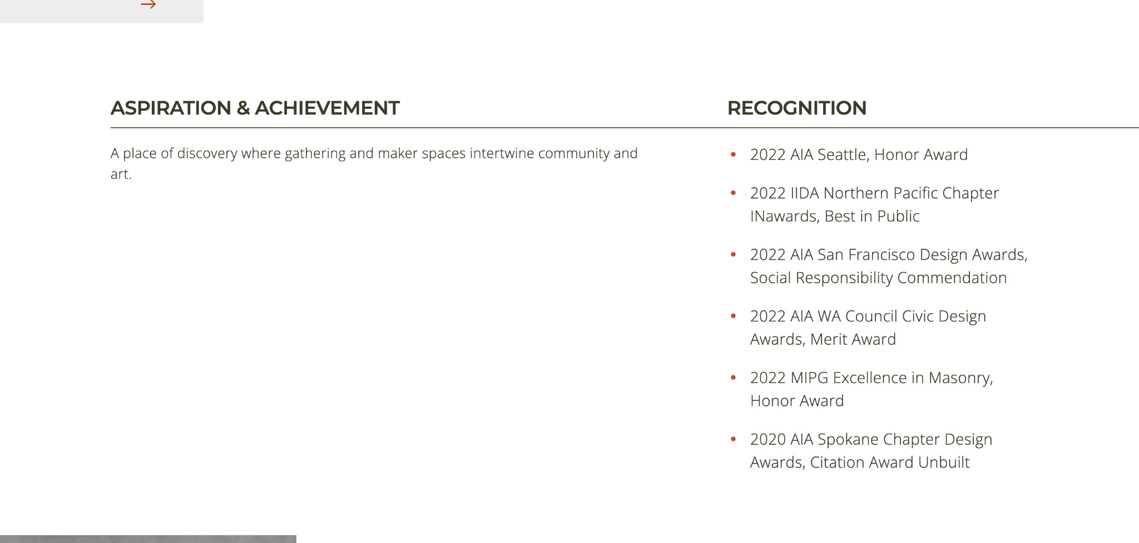

4. Team member quote and headshot

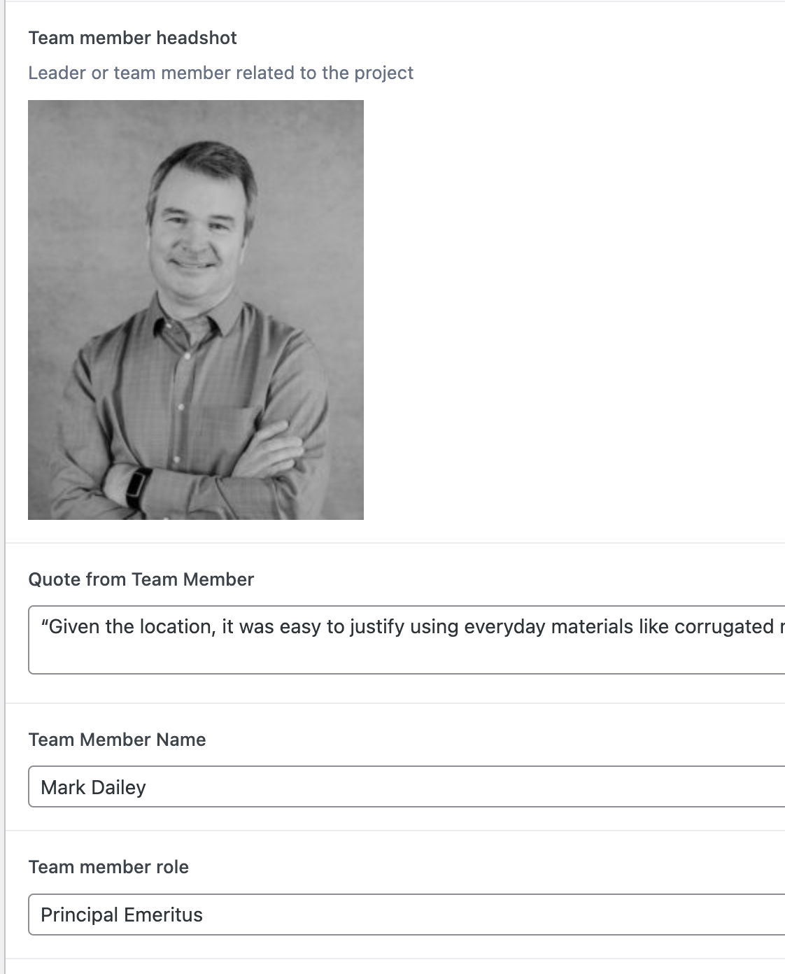

4.1 On the final page:
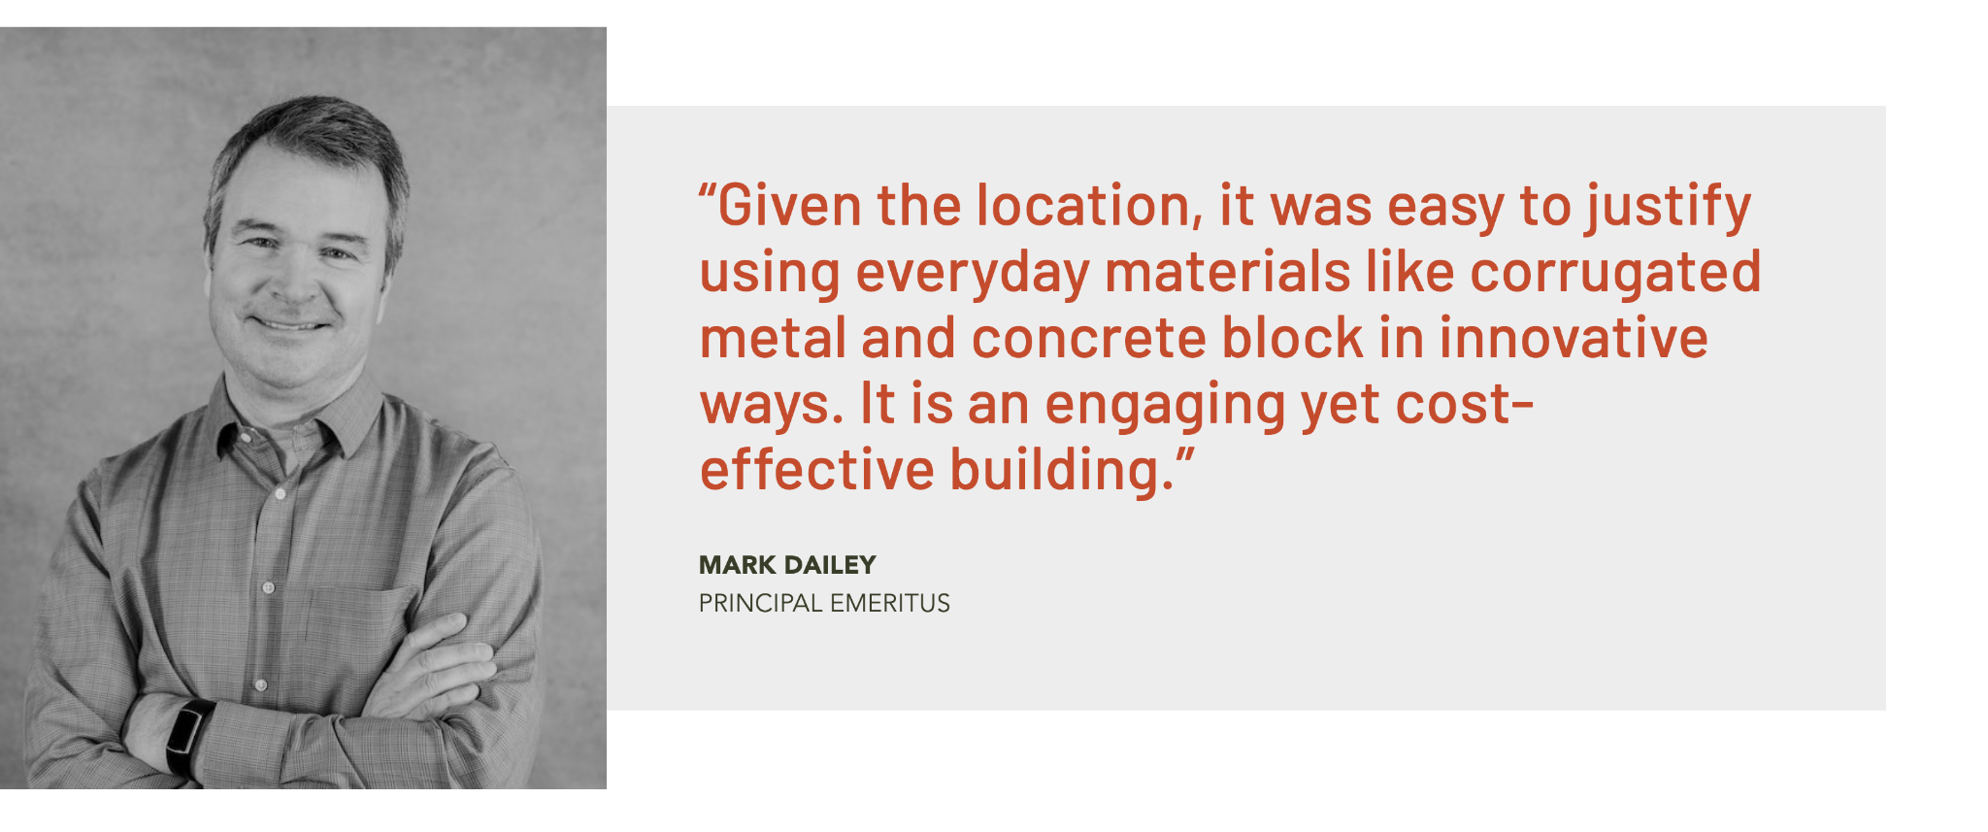

5. You will find similar fields for the client quote below

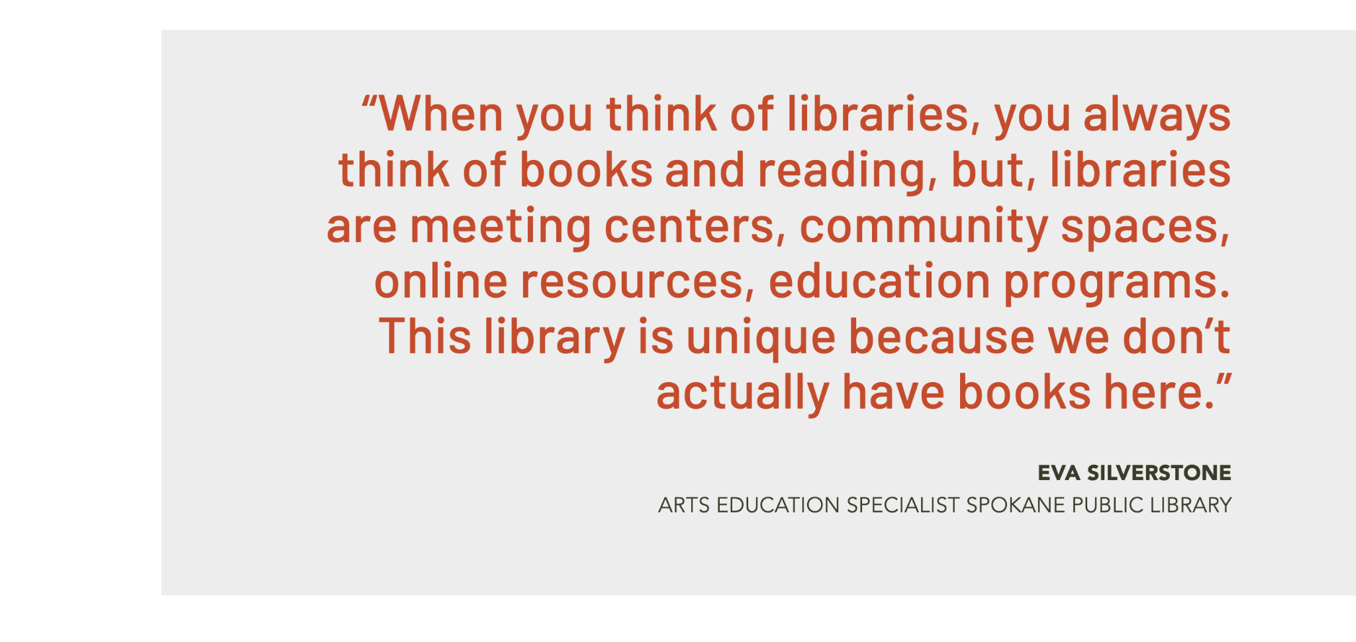

6. For images, you have three spots on the page design: The featured image, the first gallery, and the second gallery. The featured image and the rest of the images on the first gallery can be selected from the right sidebar. Please note that these images span the full width of the page. This means that larger images are needed. We recommend images with a landscape ratio and a minimum width of 2560 pixels.

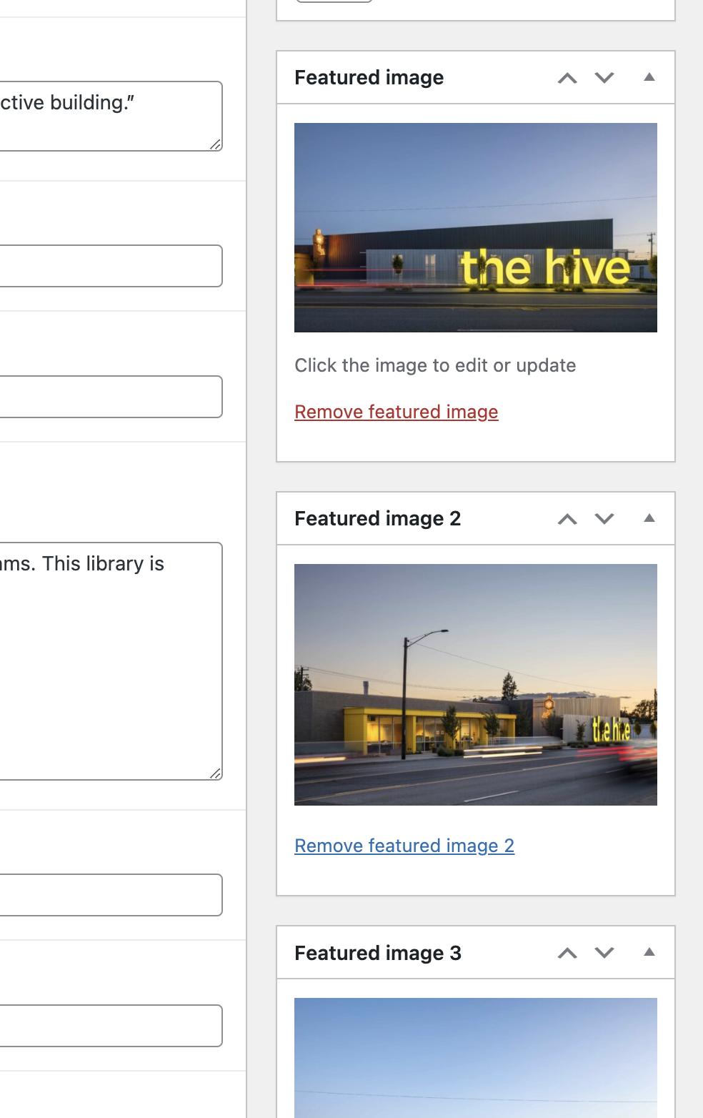
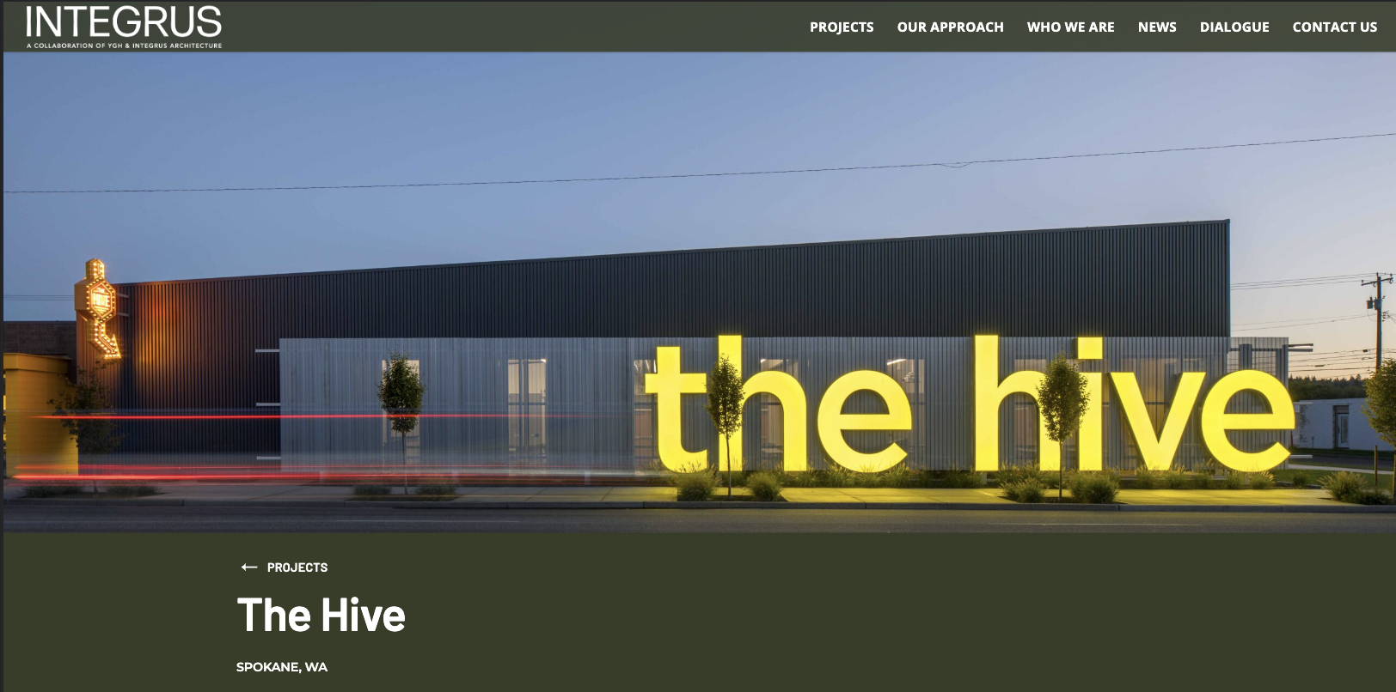
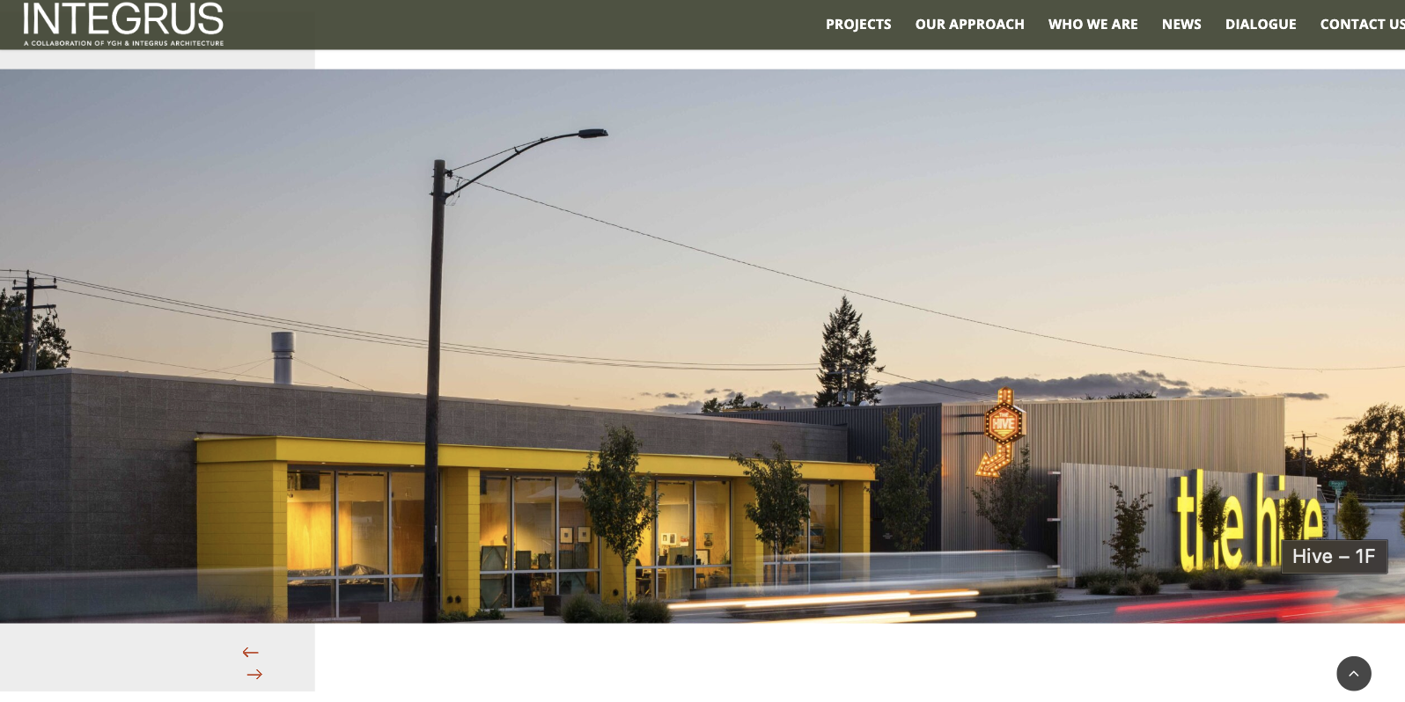

6.1 The images for the second gallery can be selected from the section below:

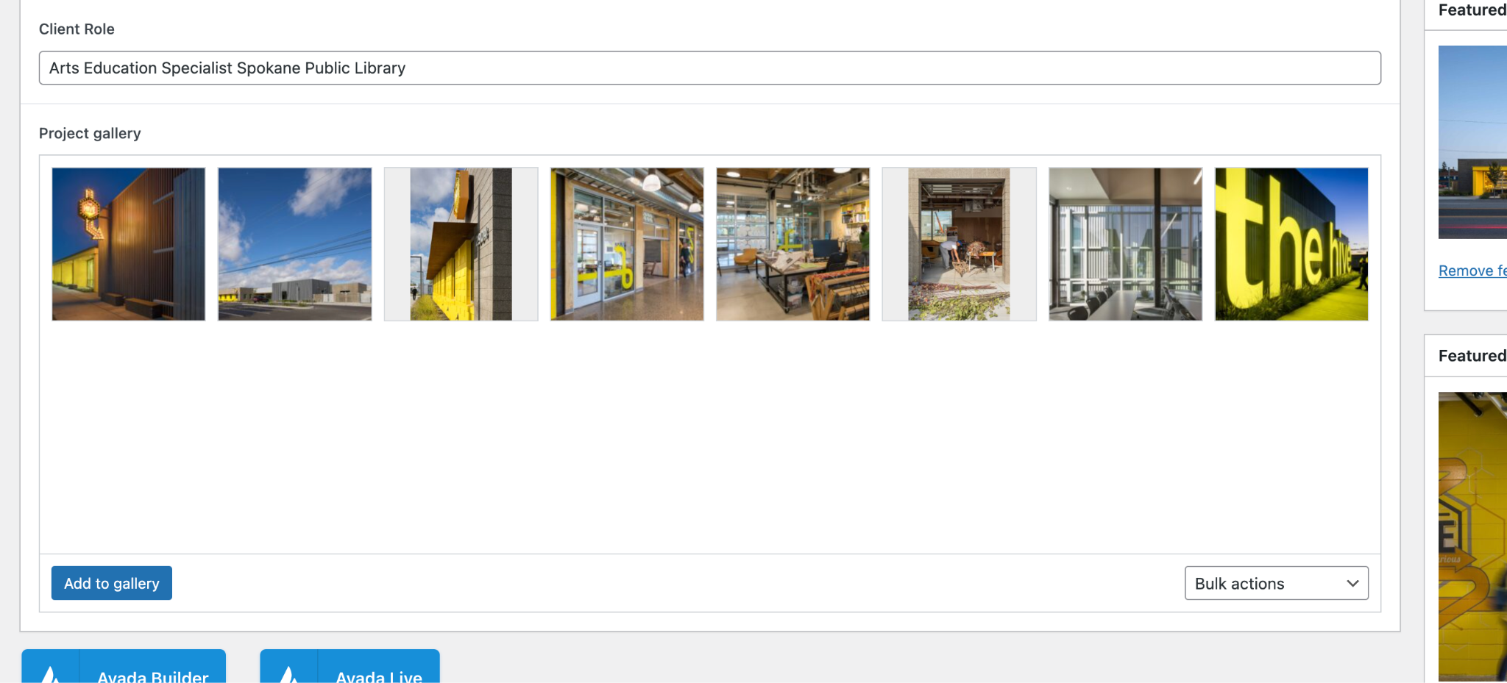
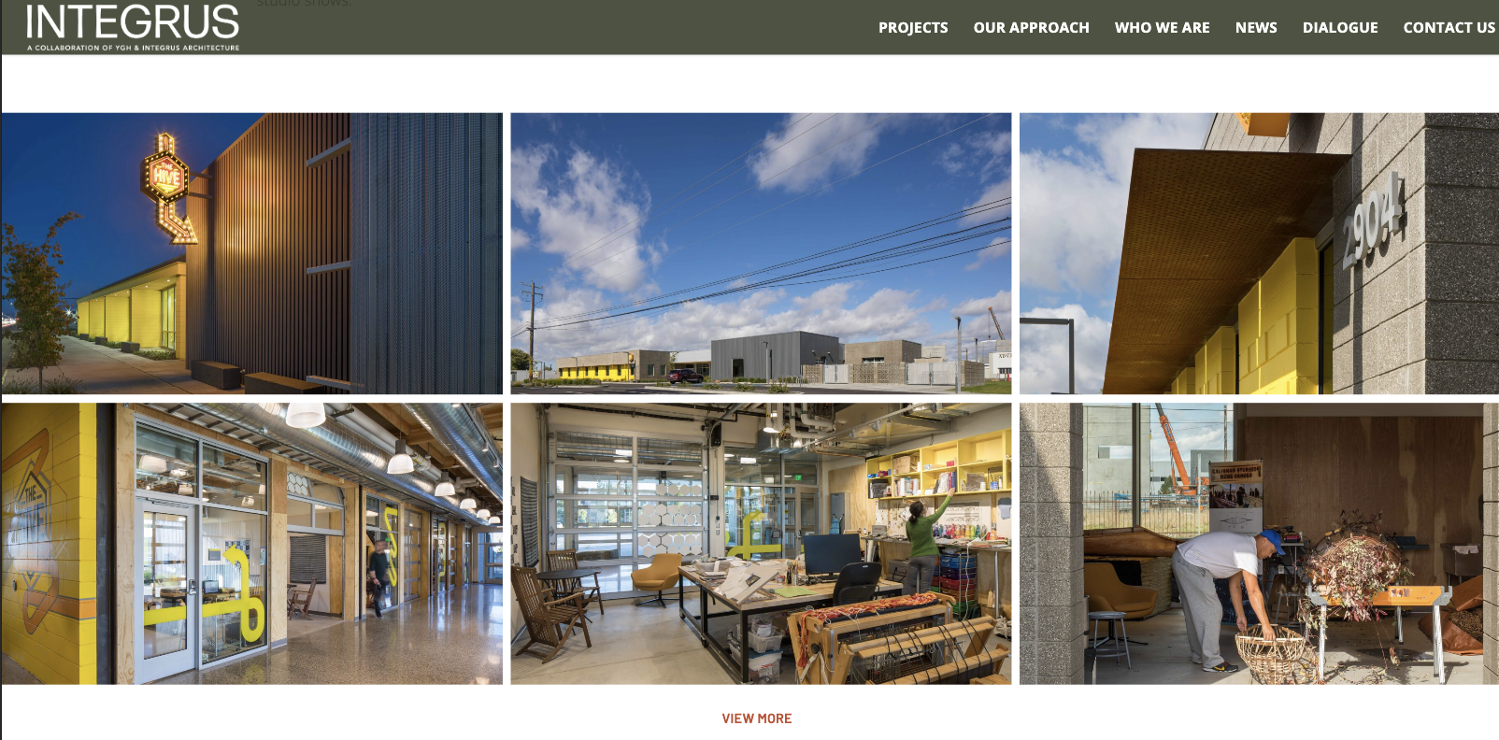

7. Once everything is ready, you can save as a draft, preview the content, or publish it right away.

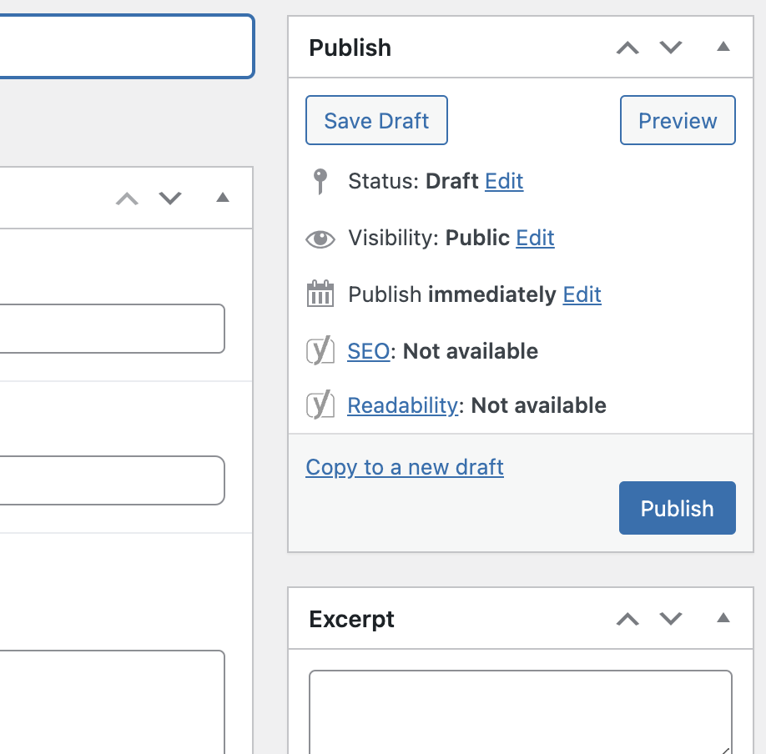

8. If any updates are made after it has been published, you will need to click on the Update button for the changes to take place.

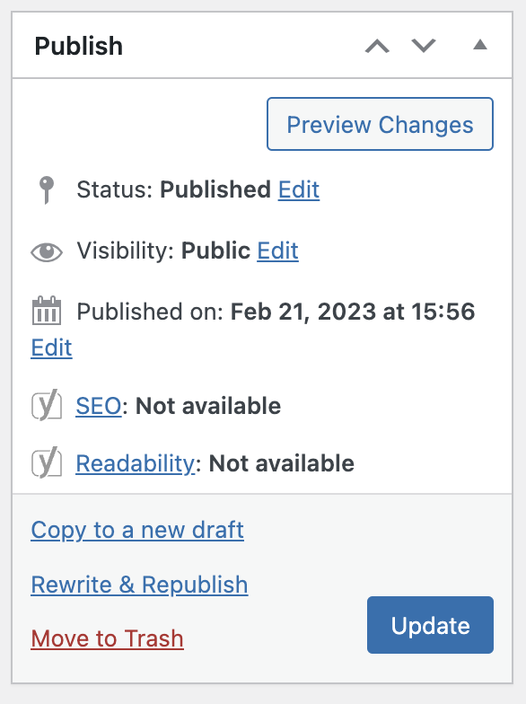

9. If you need to unpublish it, just click on the edit button next to the status and set it back to draft. Alternatively, you can just delete it by clicking on Move to Trash.

Homepage: Update Project or Blog/News

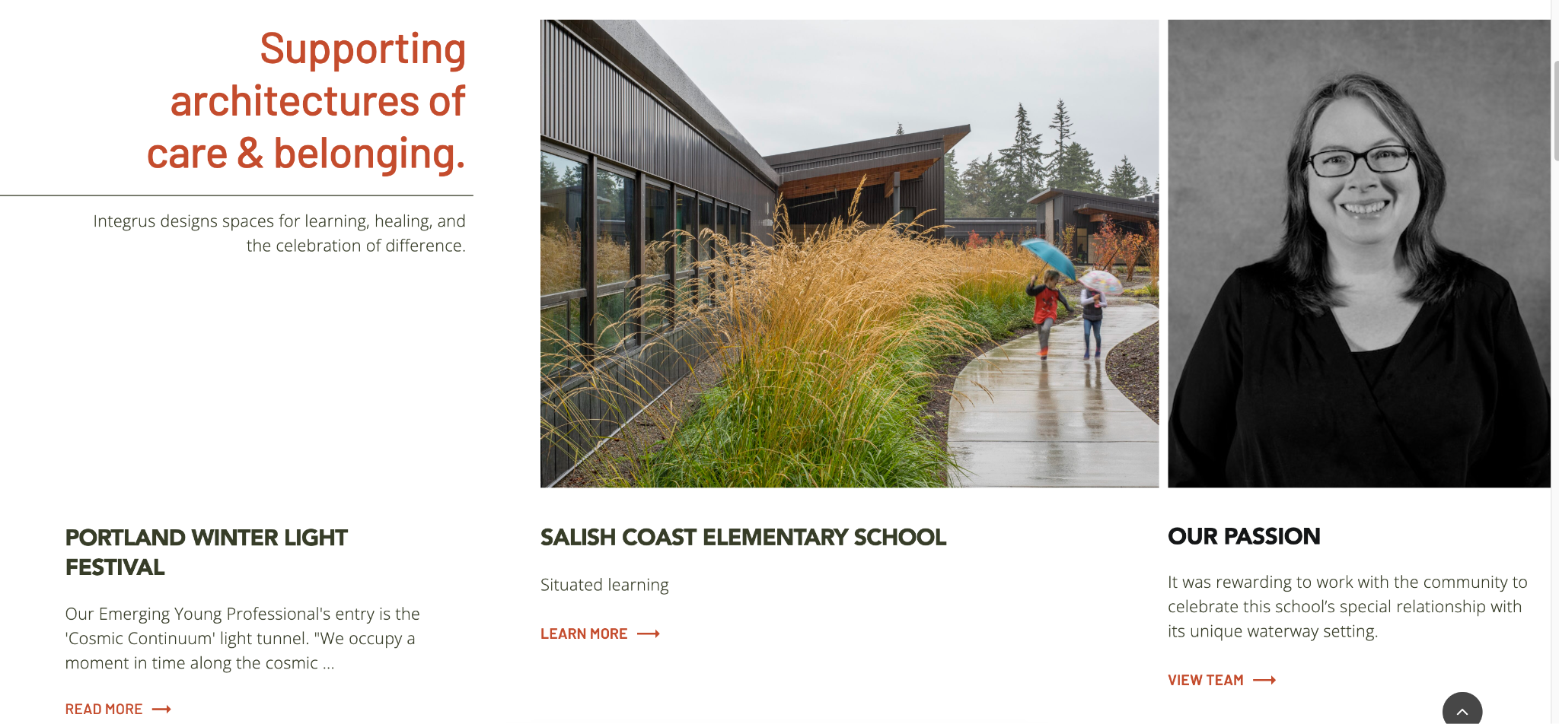

1. Go to the project or blog post you want to place on the homepage and create a tag for it. You will find this option on the right sidebar. Just copy the title and save it as a tag:

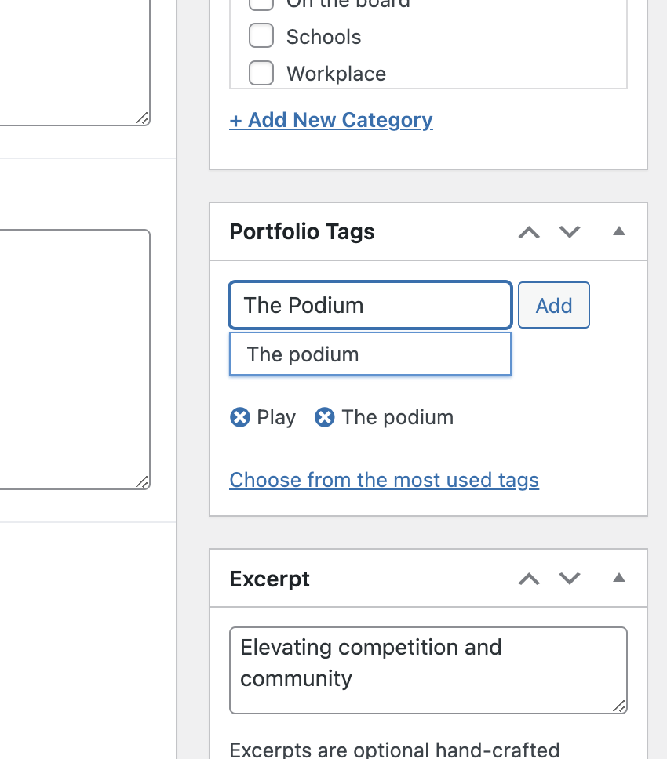

2. Next, go to the homepage and find the component where you will replace the project (the one that says "layout=grid, tags=the podium") and click on the pen icon.

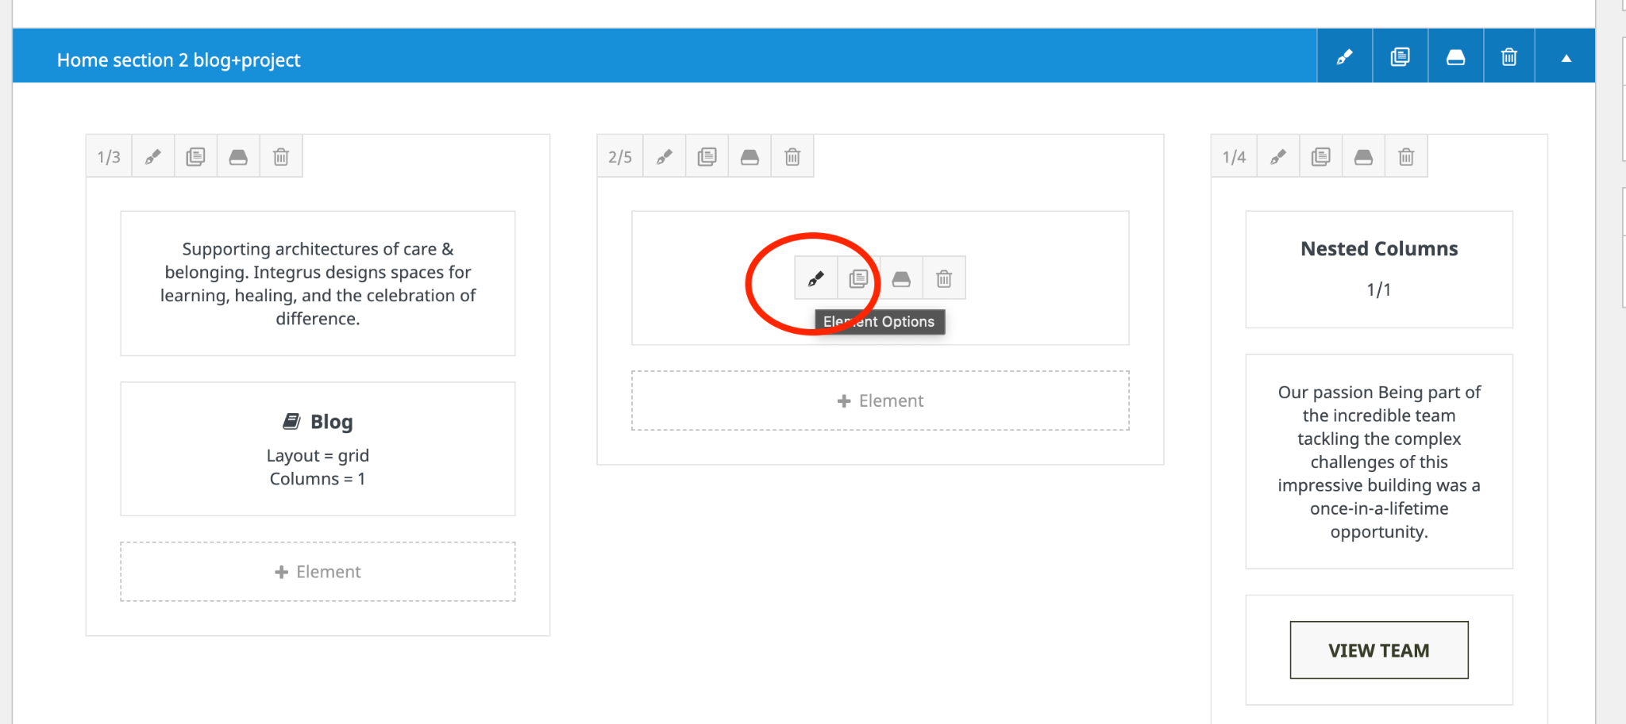

3. Finally, scroll down on the window that popped up until you see the option to change the tag. Remove the current tag and add the new one you just created:

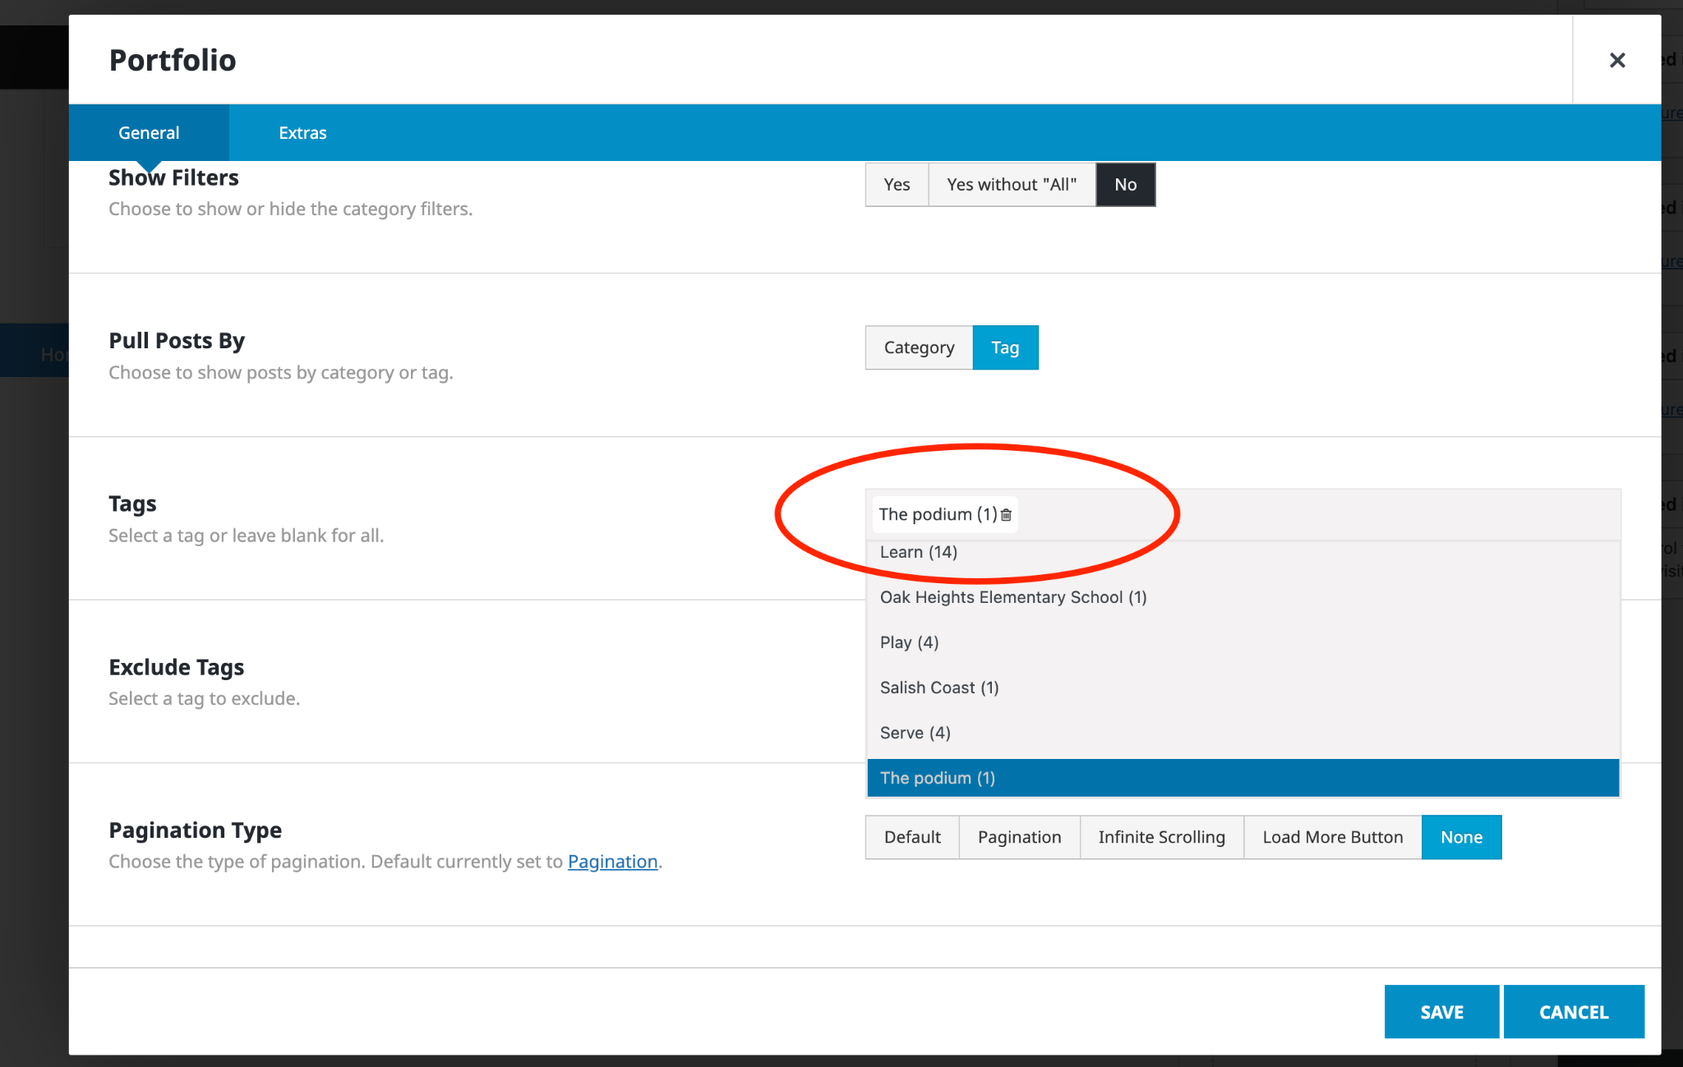

4. If you save your changes and publish the page, you should see the new project or blog post up on the homepage.

5. To update the blogs, you have to click on the component to the left or right of the project (depending on the section of the homepage). The settings you have to update are exactly the same as the ones for a project.

6. To update the headshots on those components, click the pen icon on the block that says “Nested Columns”

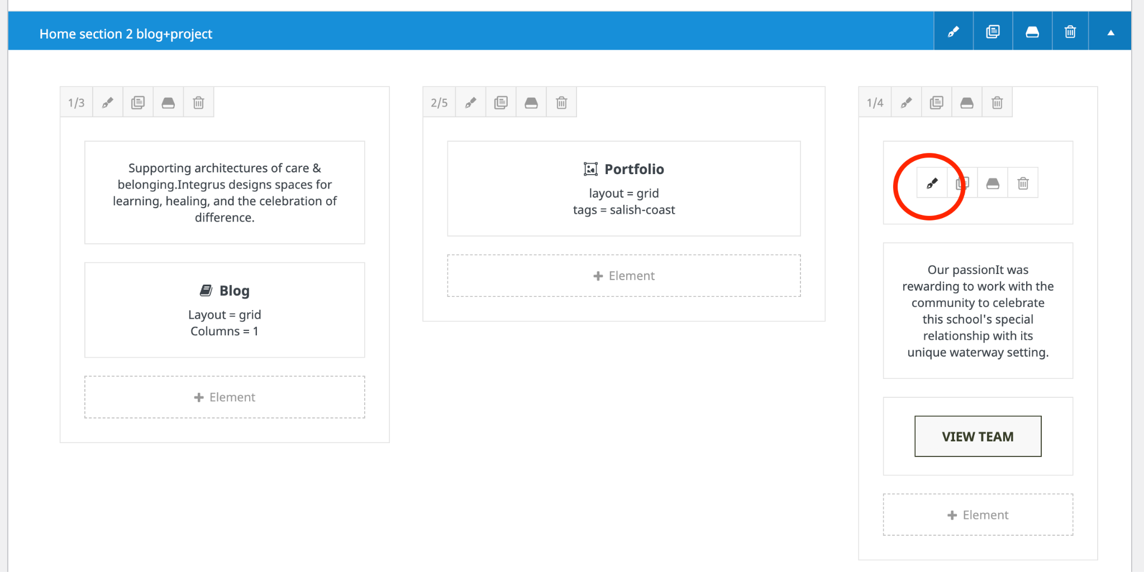

7. Again, click the pen icon on the block within that block.

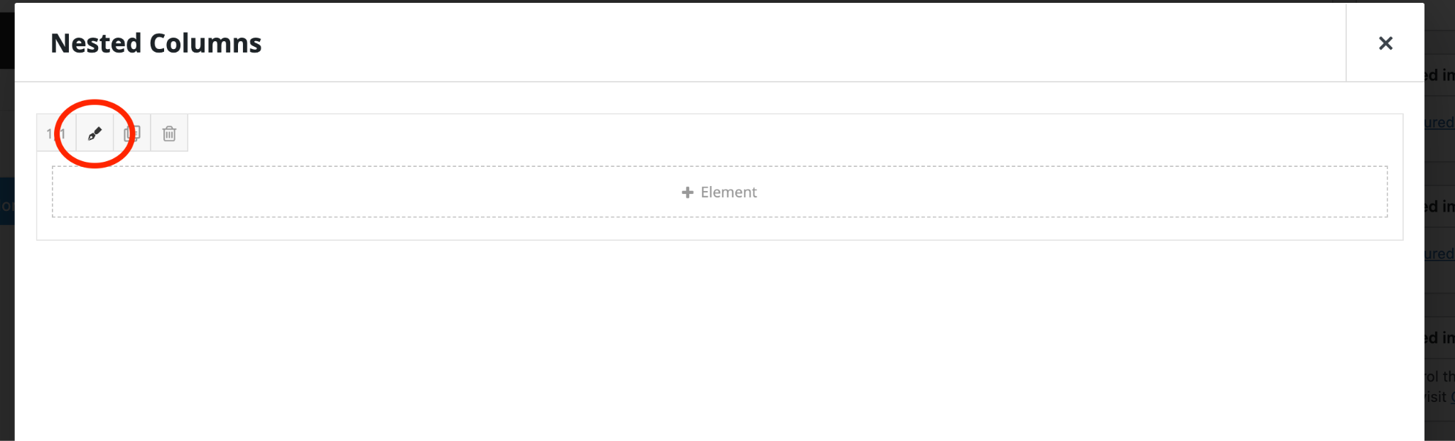

8. Click on the Background tab and, inside, on the Image tab. You will see an option to replace the headshot of the team member. Just choose a photo from the asset manager or upload a new one.

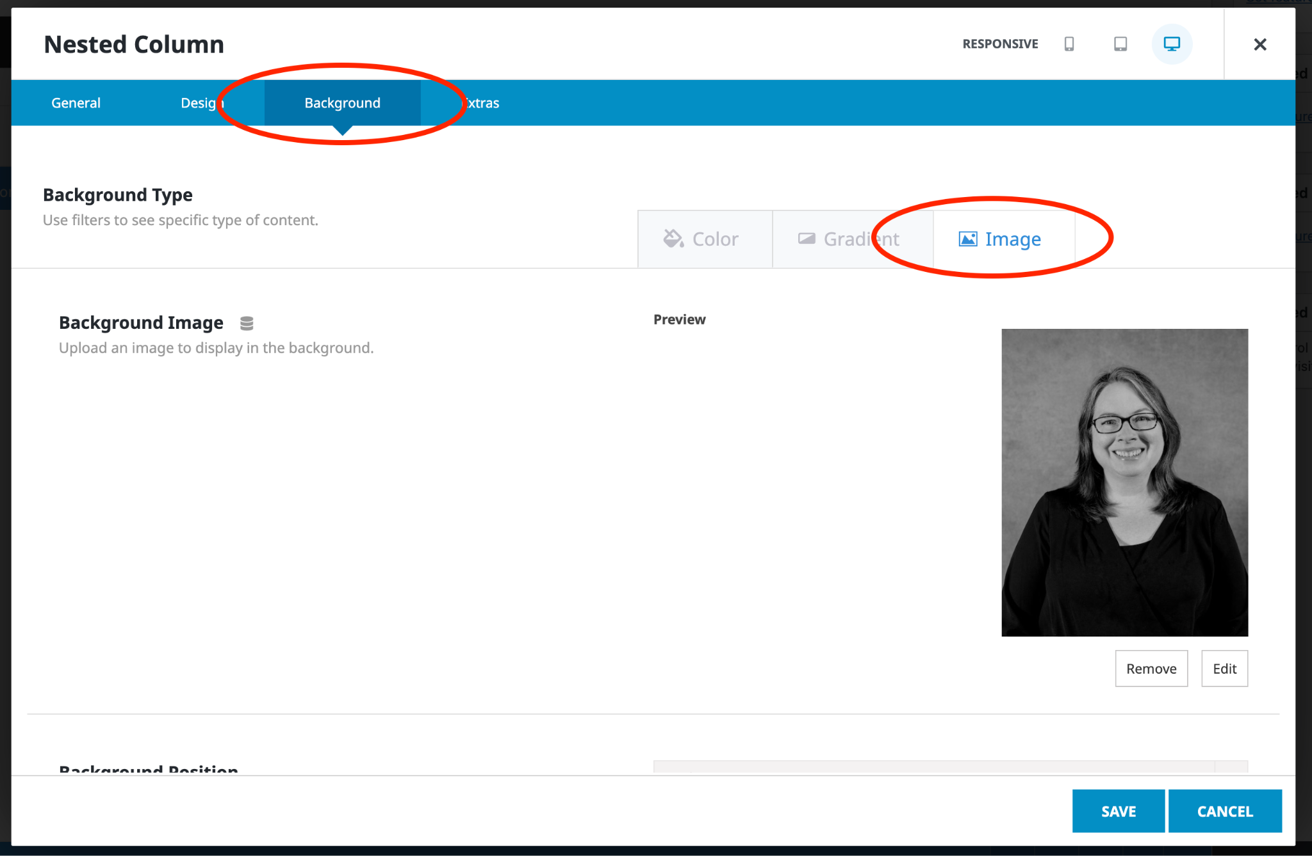

Update Filter Order for Projects
1. To update the order in which the filters appear on the Projects page, click on Taxonomy Order within the Portfolio submenu of the left sidebar.
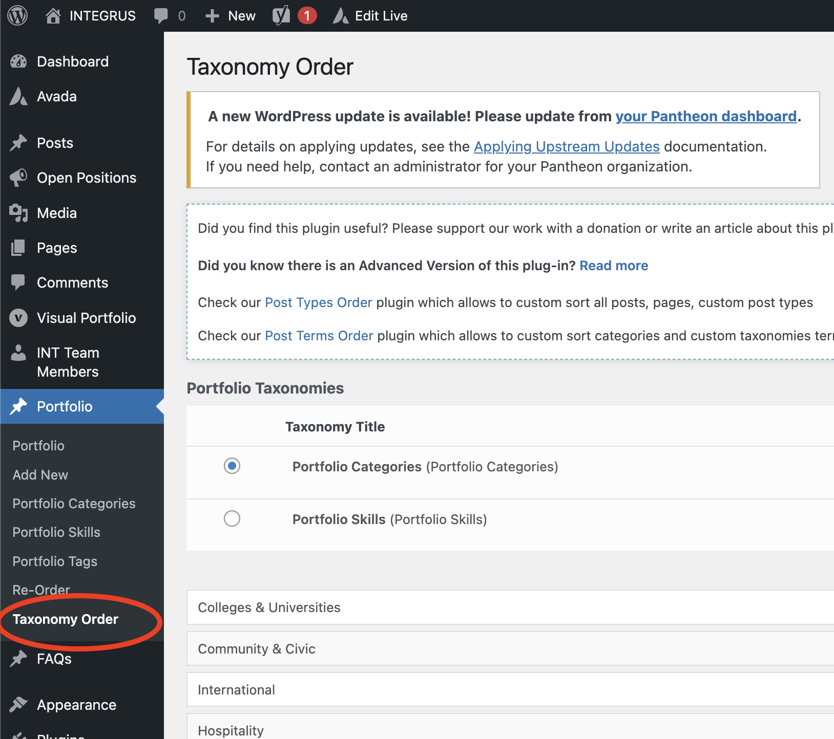

2. Here you will be able to drag and drop the different categories so that they are sorted alphabetically or in the order they are needed.

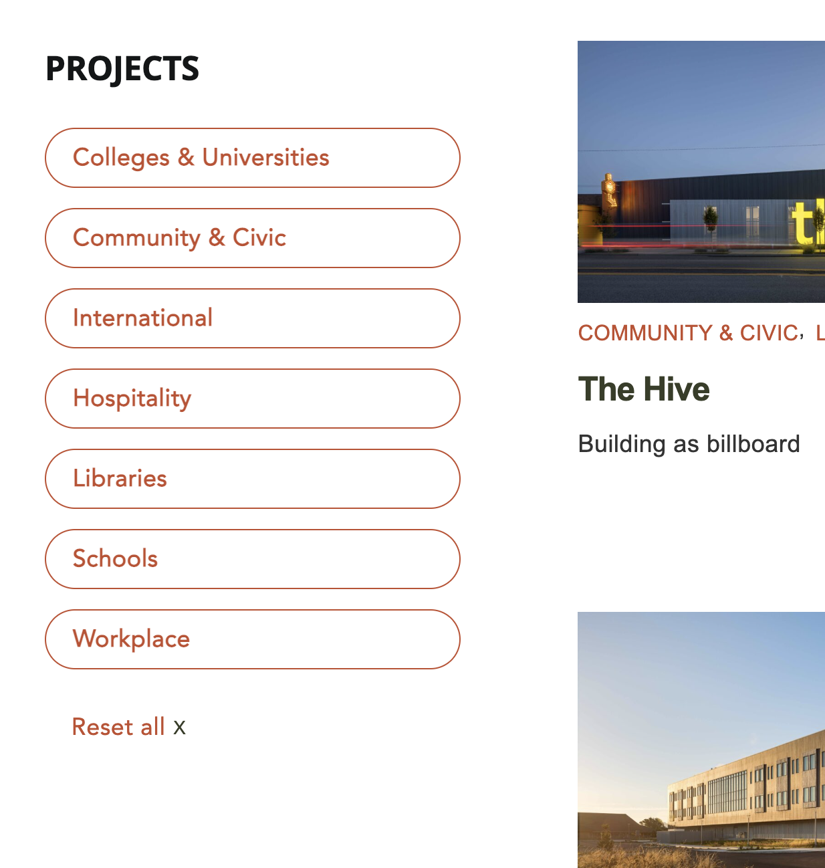

Add a New Blog/News Post
1. Inside the WordPress left sidebar, click on Posts. You will be taken to the Posts list where you can manage all News and Blogs. Click on Add New or clone an existing post to create a new post.

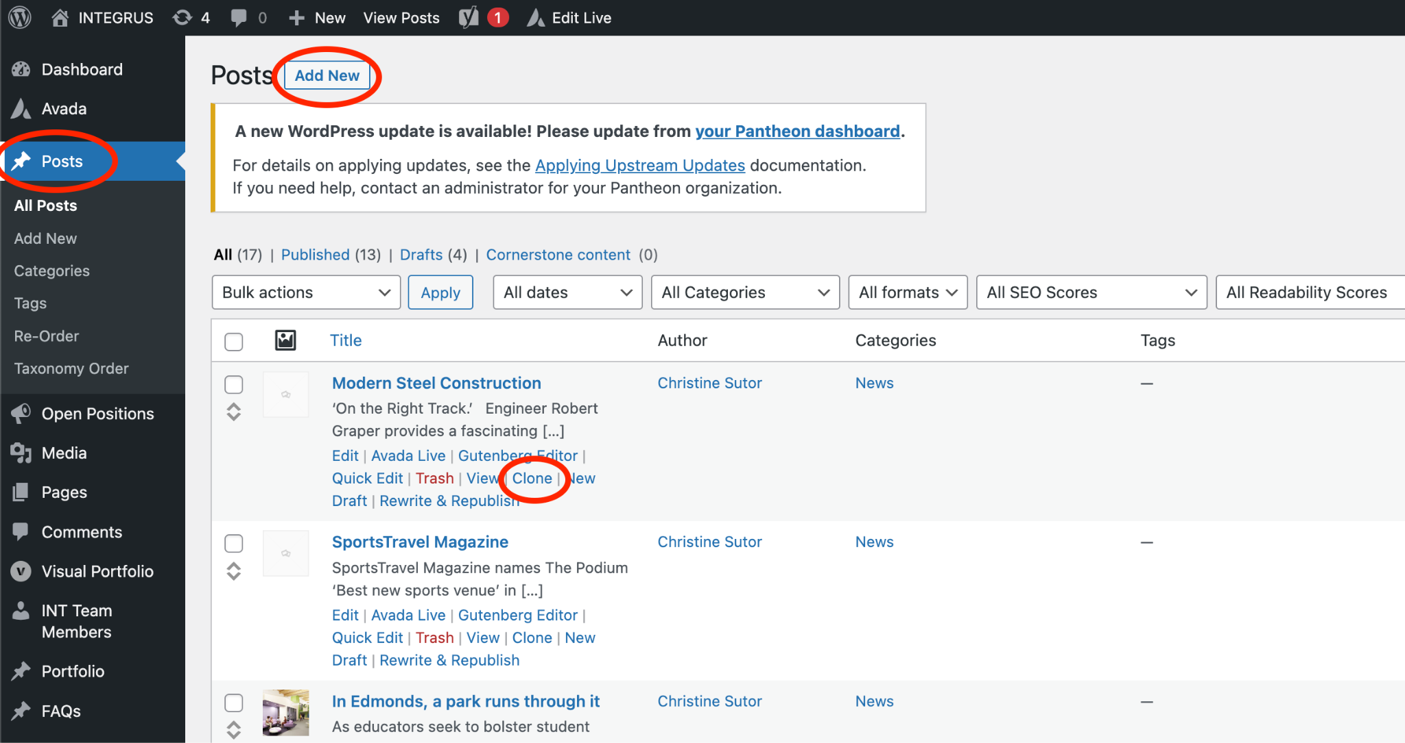

2. Add a title and body to the new post. Remember that you can check the HTML of the body by clicking on the Text tab in the editor. This will let you spot tags that might cause your text to appear differently. It normally happens if you copy and paste text that has already been formatted, or was copied from Microsoft Word.

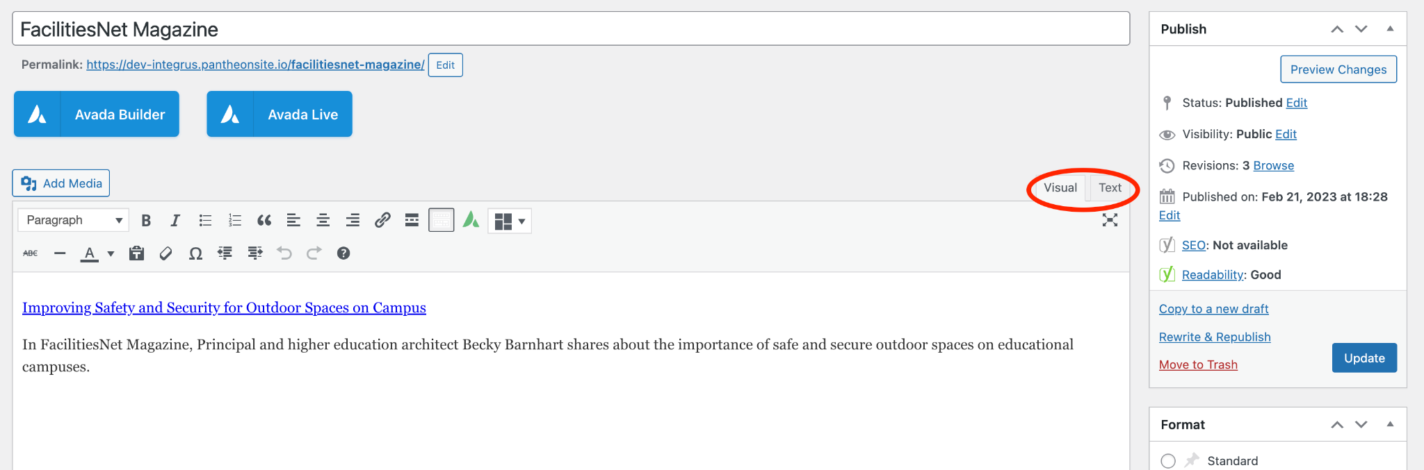

3. To differentiate between a News post and a Blog (Dialogue), select the correct category from the checklist on the right column. In this case, the only relevant categories are News and Blog. Right below you will see the Tags box, where you can assign a unique tag if you want this post to appear on the homepage.

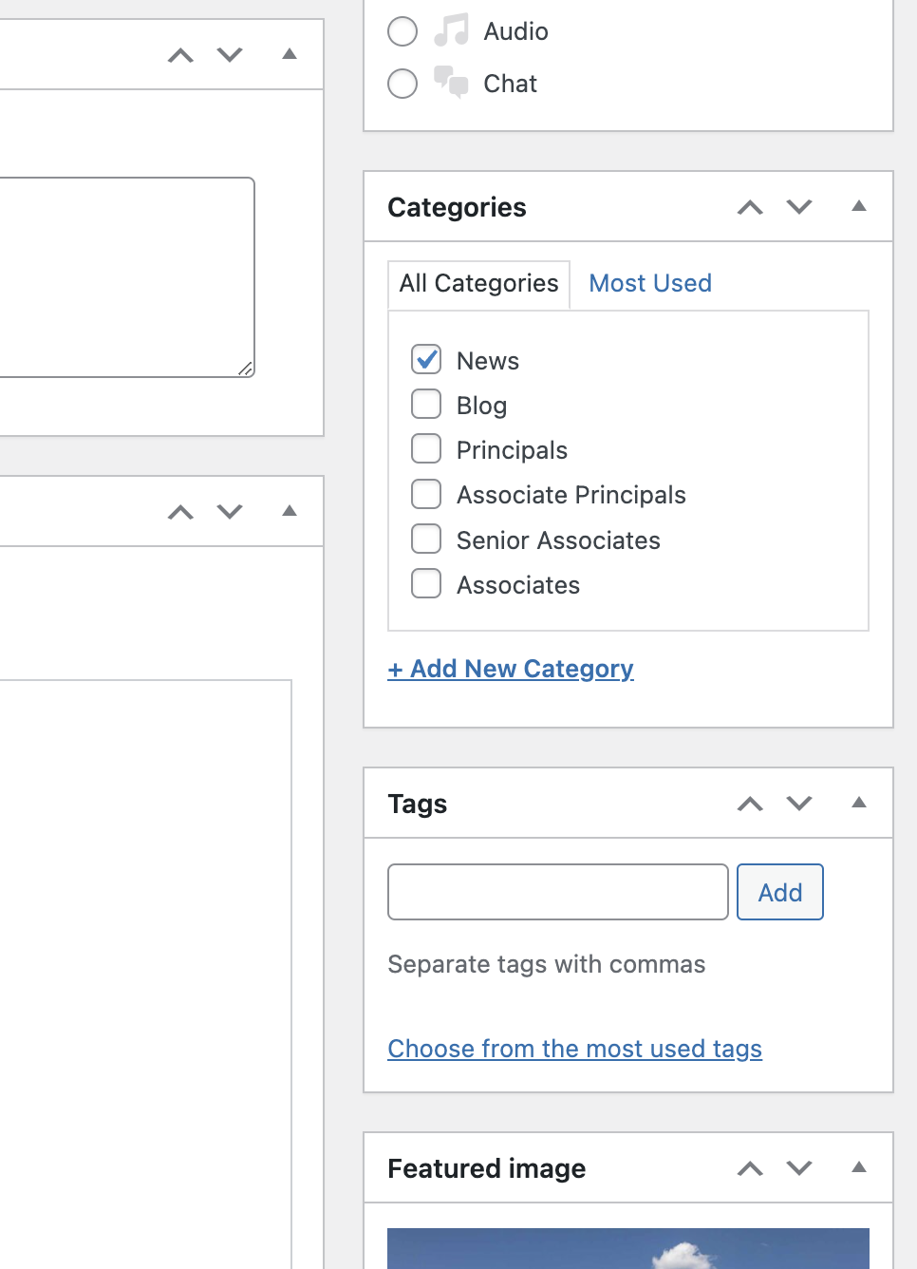

4. Right below the categories and tags on the right column, you will find the Featured image. Here you will be able to select or upload an image to be used. These images span the full width of the page, just like in projects. We recommend images with a landscape ratio and a minimum width of 2560 pixels.

5. You can save as a draft, preview the content, or publish it right away.

6. If any updates are made after it has been published, you will need to click on the Update button for the changes to take place.

7. If you need to unpublish it, just click on the edit button next to the status and set it back to draft. Alternatively, you can just delete it by clicking on Move to Trash.

Add a New Team Member
1. Go to INT Team Members in the left sidebar of the WordPress Dashboard. You will be taken to the list of team members. From here you can click on Add New or clone an existing team member.

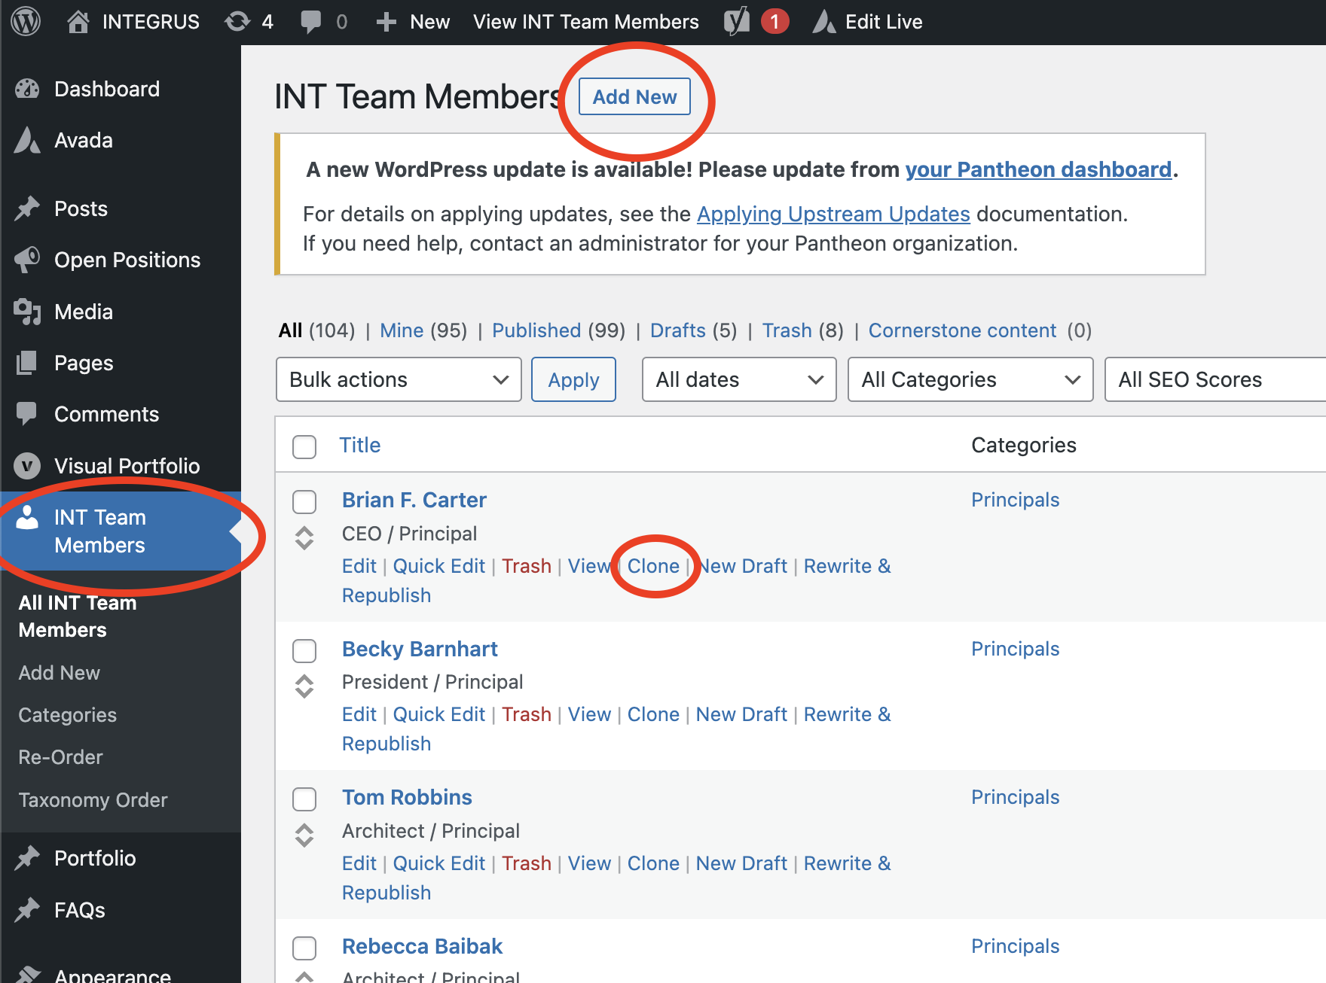

2. Add the Name in the top text box, and then continue down to fill in Credentials, Role, and Bio Quote.

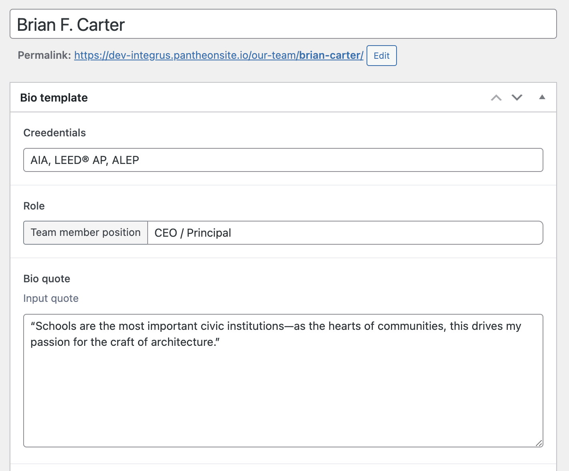

3. Below you will be able to fill in the bio-content, and the Bio Award (up to 4).

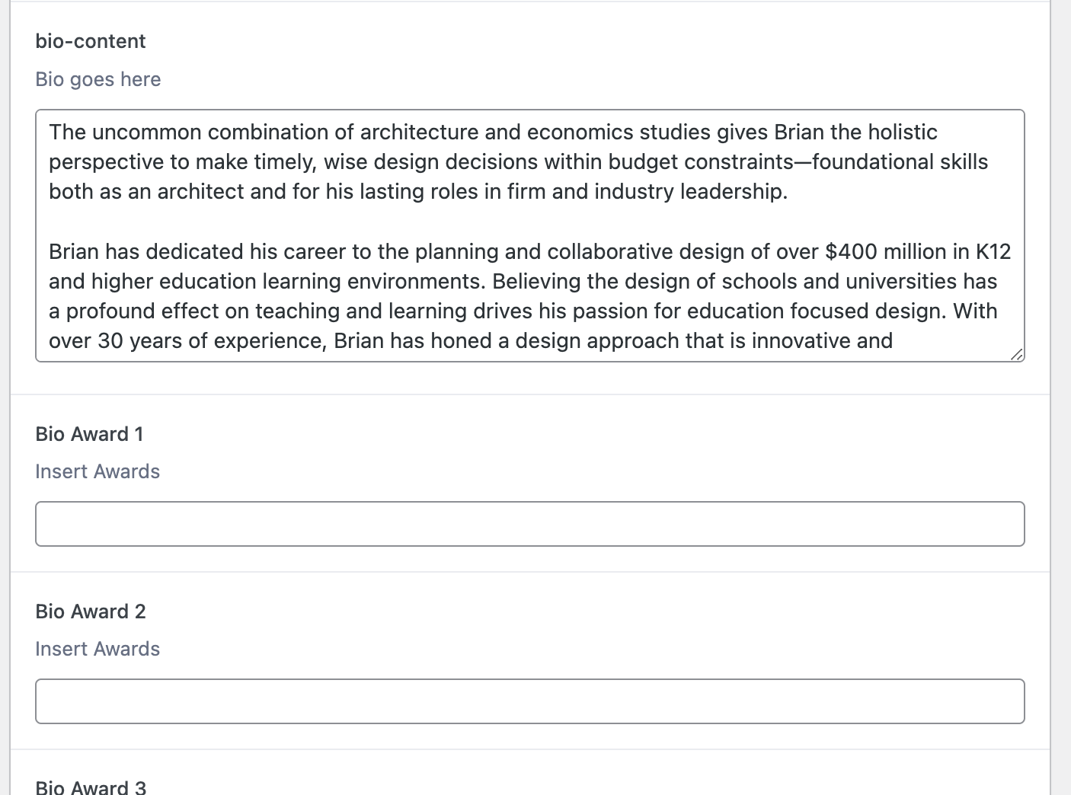

4. To the right, you will find the option to write an Excerpt. You want to write the role of the team member here again so that it shows up when hovering over their picture on the team grid. Right below, you will have the option to select or upload a headshot image.

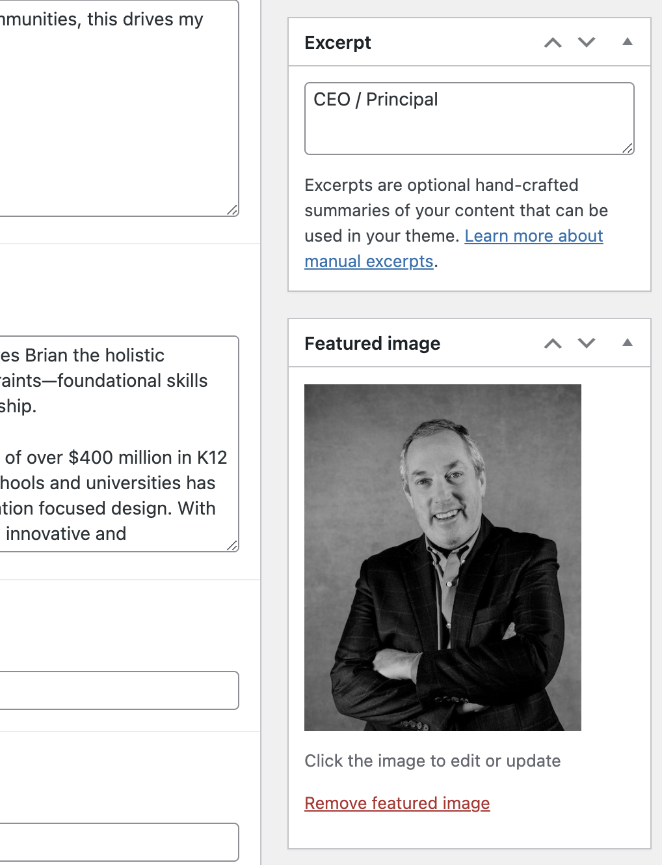

5. At the bottom of the right column you have the option to select a category for that team member. Click on the checkbox if they belong to one of the groups that we can use as filters on the website.

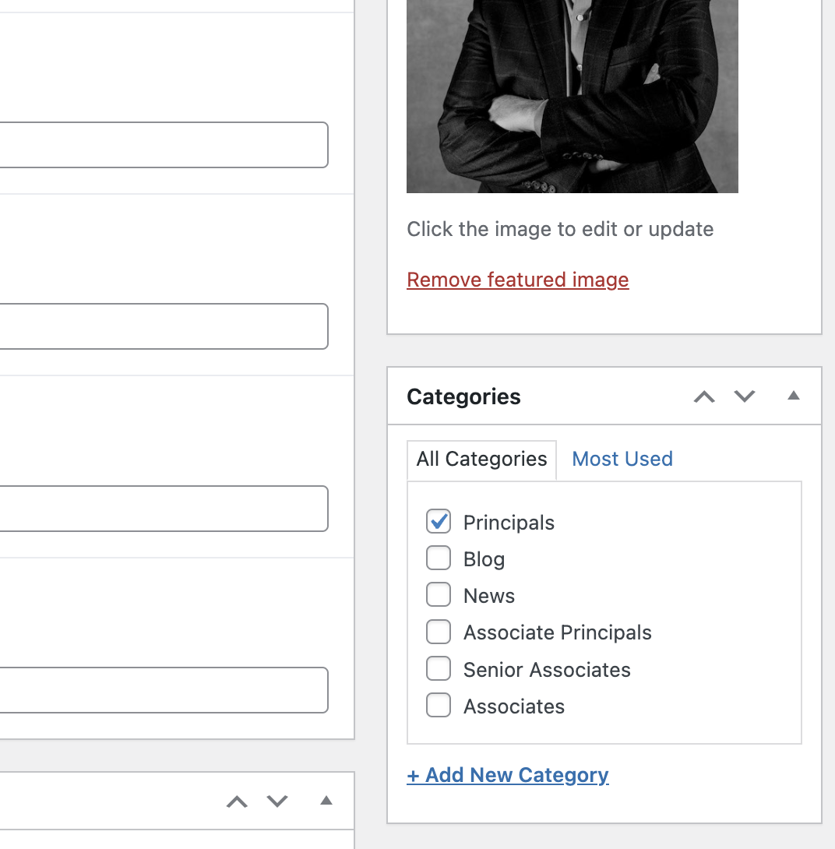

6. You can save as a draft, preview the content, or publish it right away.

7. If any updates are made after it has been published, you will need to click on the Update button for the changes to take place.

8. If you need to unpublish it, just click on the edit button next to the status and set it back to draft. Alternatively, you can just delete it by clicking on Move to Trash.

Add a New Open Position
1. Inside the WordPress left sidebar, click on Open Positions. You will be taken to the Open Positions list where you can manage all the job postings listed on the Careers page. Click on Add New to create a new post.

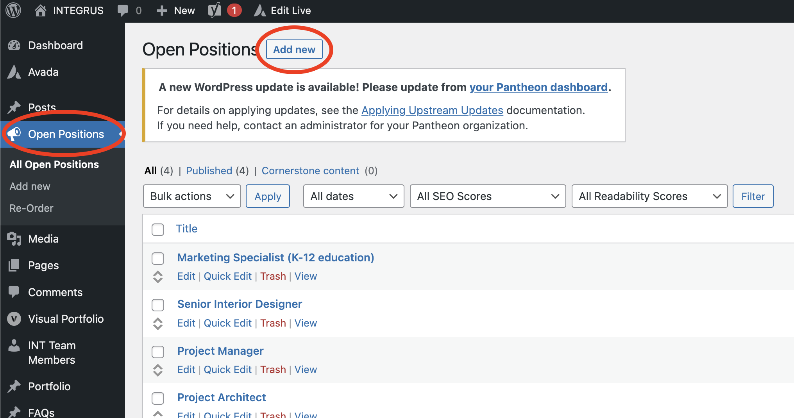

2. After adding the position title, you can add the Open Position details. Right below you can add a location and a link. This is where you can link the position directly to the same page from The Deltek platform. By clicking on the Add Position Location, and then on Location, You will have the option to add a new location and link to the position.

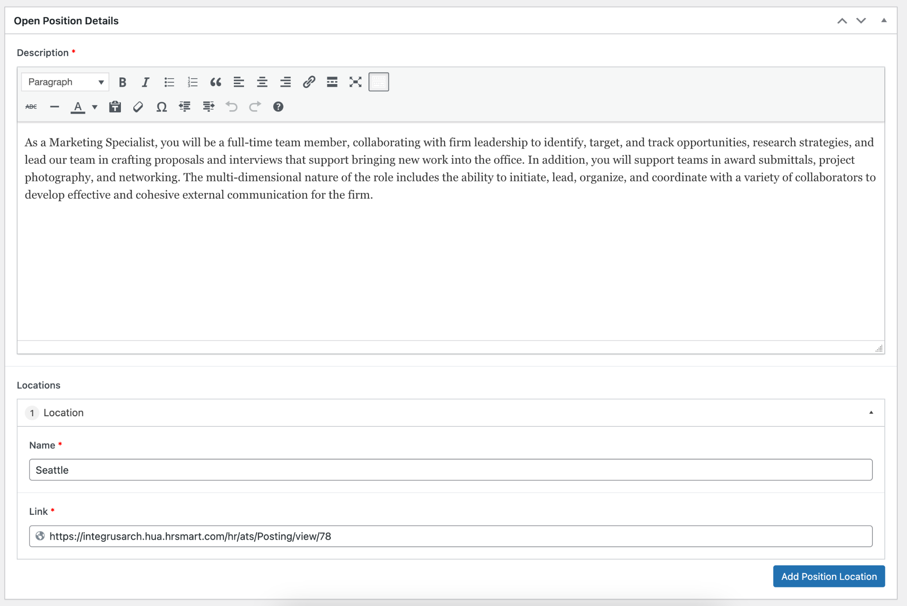

3. When finished, you can save it as a draft or publish it live.

